**Comparators and Equality**

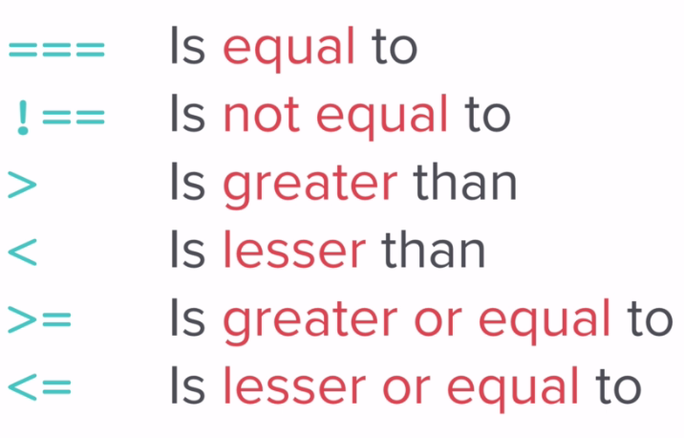

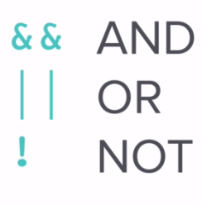

**Difference between two equal signs = = and three equal signs = = =**

**Two equal signs = =** check equality only while **three equal signs = = =** check equality as well as data types.

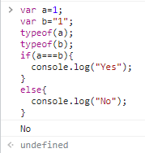

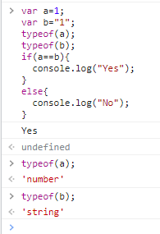

prompt("What is your name?");

prompt("What is their name?");

var loveScore = Math.random()*100;

loveScore = Math.floor(loveScore)+1; //1-100

if(loveScore===100){

alert("Your love score is: "+loveScore+"%. You love each other like Kanye loves Kanye");

}

if(loveScore>70){

alert("Your love score is: "+loveScore+"%. You are lucky");

}

else{

alert("Your love score is: "+loveScore+"%");

}

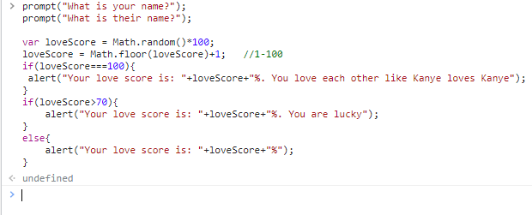

prompt("What is your name?");

prompt("What is their name?");

var loveScore = Math.random()*100;

loveScore = Math.floor(loveScore)+1; //1-100

if(loveScore==100){

alert("Your love score is: "+loveScore+"%. You love each other like Kanye loves Kanye");

}

if(loveScore>70){

alert("Your love score is: "+loveScore+"%. You are lucky");

}

else{

alert("Your love score is: "+loveScore+"%");

}

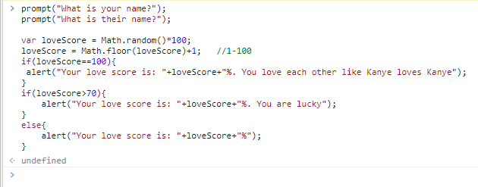

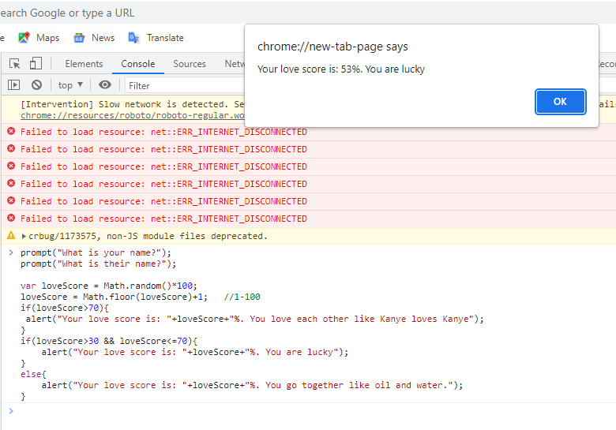

prompt("What is your name?");

prompt("What is their name?");

var loveScore = Math.random()*100;

loveScore = Math.floor(loveScore)+1; //1-100

if(loveScore>70){

alert("Your love score is: "+loveScore+"%. You love each other like Kanye loves Kanye");

}

if(loveScore>30 && loveScore<=70){

alert("Your love score is: "+loveScore+"%. You are lucky");

}

else{

alert("Your love score is: "+loveScore+"%. You go together like oil and water.");

}

Comparison operators compare two values and give back a boolean value: either true or false. Comparison operators are used in [decision making](https://www.programiz.com/javascript/if-else) and [loops](https://www.programiz.com/javascript/for-loop).

